# Introduction to Computer Science and Programming 1

# CSCI120

### Sample Midterm

**Note:** This document has been designed and developed as part of an initiative for creating an OER (Open Education Resource) package for the course CSCI 120 at Columbia College.

Please contact [Alireza.davoodi@gmail.com](mailto:Alireza.davoodi@gmail.com) for any comment, modification, and questions.

**Terms of use:** Please feel free to customize this document as needed

Last Modified: July 2022

# Questions’ Points Table

|  |  |
| --- | --- |
| *Question* | Score |
| 1 (10pt) |  |
| 2 (15pt) |  |
| 3 (15pt) |  |
| 4 (15pt) |  |
| 5 (10pt) |  |
| 6 (20pt) |  |
| 7(15pt) |  |
| T**otal (105pt)** | **( ) /100 points** |

# Problem1: Coding (10 points)

Suppose a list of positive numbers is given like the following list (remember this is only an example and the list could be any list of positive numbers)

exampleList:

|  |  |  |  |  |  |  |  |  |
| --- | --- | --- | --- | --- | --- | --- | --- | --- |
| 15 | 19 | 10 | 11 | 8 | 7 | 3 | 3 | 1 |

We would like to know the “prime visibility” of each index of the list. The “prime visibility” of a given index shows how many numbers in the list with indexes lower than the given index are prime. For instance, in the examplList, the “prime visibility” of the index 4 is 2 because there are 2 numbers (19 and 11) before index 4 that are prime.

To solve this problem, design and implement a function called primeVisibility with two parameters:

1. The list of numbers
2. The index

The function finds and returns the “prime visibility” of the given index.

# Problem2: Design and Programming (15 points)

* Imagine a PolynomialEquation is a mathematical equation with only one base factor. For instance the followings are examples of PolynomialEquations with one base factor, which is “x”:
  + Note: The ^ operator is the power operation. For instance, 2^3 = 2*2*2 = 8

Some examples of PolynomialEquations

* + 5*x^4 – 3*x^2 + 6
  + 10*x^5 + 8*x^4 + x^2 + 5
  + 2*x^2
  + 4*x^3 + 5
  + 10
* Also, suppose each PolynomialEquation is composed of one or more SinglePolynomialFactors. Each SinglePolynomialFactor is composed of three following properties (data):
  + coefficient
  + baseFactor
  + exponent
* Examples:
  + -3*x^7: Is a SinglePolynomialFactor with (coefficient=-3, baseFactor = ‘x’, exponent=7)
  + 5: Is a SinglePolynomialFactor (coefficient=5, baseFactor = ‘x’, exponent=0)
  + 4*x: Is a SinglePolynomialFactor with (coefficient=4, baseFactor = ‘x’, exponent=1)
* Let’s look at one more example to make sure you understand what a PolynomialEquation and a SinglePolynomialFactor is. For example, look the following table which shows some PolynomialEquations and their SinglePolynomialFactors.

|  |  |
| --- | --- |
| PolynomialEquation | SinglePolynomialFactors |
| 5*x^4 – 3*x^2 + 6 | 5*x^4  – 3*x^2  6 |
| 10*x^5 + 8*x^4 + x^2 + 5 | 10*x^5  8*x^4  x^2  5 |
| 2*x^2 | 2*x^2 |
| 4*x^3 + 5 | 4*x^3  5 |
| 10 | 10 |

Now answer the following question:

* **Question1:** What data structure (data type) would you use to represent a SinglePolynomialFactor? Show an example.
* **Question2:** What data structure (data type) would you use to represent a PolynomialEquation.
* **Question3:** Two SinglePolynomialFactor are considered the same, if they have the same coefficient, baseFactor and exponent. Design an implement a function as following:
  + The name of the function: checkSingleFactorEquality
  + Parameters of the function: Two SinglePolynomialFactors
  + Return type: The function will return True if the two given SinglePolynomialFactors are equal, otherwise it returns False.
* **Question4:** Two PolynomialEquations are considered equal if they have exactly same SinglePolynomialFactors in the same order. If they have the same SinglePolynomialFactors but in a different orders, they are not considered as equal. Now design and implement a function as following:
  + The name of the function: check PolynomialEquationsEquality
  + Parameters of the function: Two PolynomialEquations
  + Return type: The function will return True if the two given PolynomialEquations are equal, otherwise it returns False.

**Problem3: Programming (15 points)**

* Create a function called, convert. This function receives a string parameter called word which only contains digits (the string represents a positive number) and returns a list of numbers. This is how the function works:
* This function calculates the number of times each digit has repeated in the input string and then generates a number based on that using the following formula and adds it to a list. For instance, if the digit x has been repeated n times, then the function will calculate n*10+x and adds it to the list. (See the example)

Example input: “6743672316”

In the above string:

* 6 is repeated 3 times. Then the corresponding number to be added to the list is 3*10+6 = 36
* 7 is repeated 2 times: The number to be added to the list 2*10+7 = 27
* 4 is repeated once: The number to be added to the list is 1*10+4 = 14
* 3 is repeated 2 times: The number to be added to the list is 2*10+3 = 23
* 2 is repeated once: The number to be added to the list is 1*10+2 = 12
* 1 is repeated once: The number to be added to the list is 1*10+1 = 11

Then the functions *convert* returns the following list: [36,27,14,23,12,11]

**Note:** The order of the numbers in the list is not important.

# Problem4: Algorithm (15 points)

Consider the following flowchart and answer the following questions:

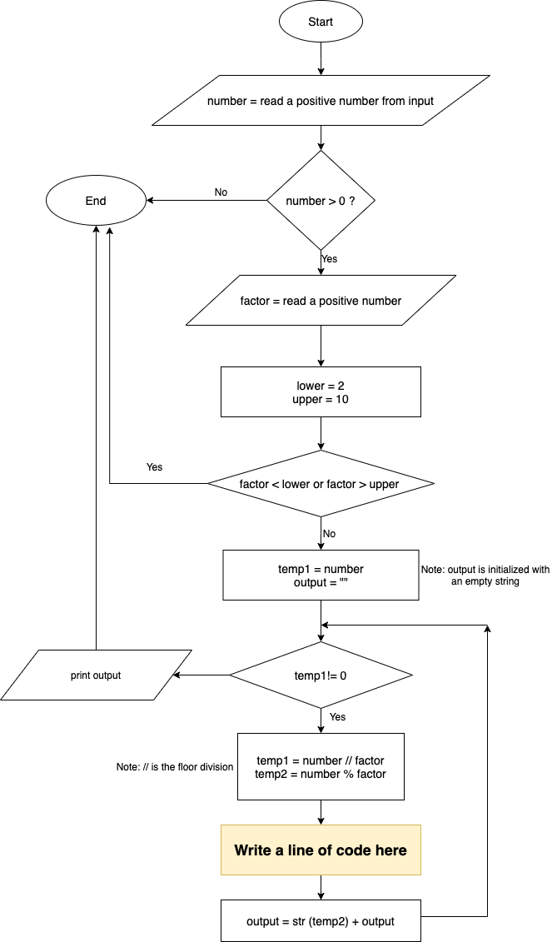

This flowchart shows an algorithm to convert a positive number in base 10 and any base between 2 and 10.

* First look at the flowchart and try to get some sense of what it does.
* **Question1:** There is one box which is yellow. You need to add one line of code there in order the algorithm completes and works properly. What is that line? If you feel more than one line is needed, feel free to add them there.
* **Question2:** What is the output of this flowchart if the user enter number =1456 and factor = 5?
* **Question3:** Do you see any other error in this flowchart to print the correct answer? If yes, what is it, otherwise, you can write “no other error”.
* **Question4:** Write a Python code for this flowchart that exactly follows the flowchart steps and components.

# Problem5: (10 points)

Imagine a table is given as following. This table is called lookup table. The table works as following. It assigns a number to some uppercase or lowercase alphabents as shown in the table.

|  |  |  |  |
| --- | --- | --- | --- |
| letter | number | letter | Number |
| A | 12 | e | 8 |
| B | 10 | f | 3 |
| F | 5 | i | 2 |
| M | 4 | m | 0 |
| N | 0 | n | 1 |
| P | 11 | p | 2 |
| Q | 10 | q | 3 |
| W | 9 | r | 4 |
| Z | 9 | s | 5 |

1. Design and implement a function with 2 parameters: 1- a string (a word) 2- a variable that represents the above lookup table. The function converts the string to a number and returns it. This function replaces each character in the string with its corresponding number from the above table. If the character does not exist in the above table, the function replaces it with 0. The function will eventually return the number.
2. Define a main function and call the method you designed in 1. When calling the above function in the main method, pass to the function the word “We have missed Vancouver’s summer” and the above lookup table. What is the output of the function for the this word, “We have missed Vancouver’s summer” ?

# Problem6: (20 points)

Answer the following questions:

**Question1:** Convert the following code to use a for-loop instead of while-loop to generate exact same results:

def function():

word = input("Enter a word [enter exit to terminate]")

count = 0

while word!="exit" and count<10:

print(word)

count = count + 1

return

**Question2:** The following snippet of code receives an input and then checks whether the input is a number. The issue with the following code is that if the user enters a negative number (like -10), the code would not work. Make some changes in this code to also work with negative numbers as well as positive numbers.

def function():

number = input ("enter a number: ")

if number.isdigit():

return True

else:

return False

**Question3:** The following snippet of code, remove vowels from a string (word) and prints the result, which is equivalent to the word without its vowel letters. Do you think this function will work as expected? If yes please explain and if no, please fix the issue(s) to generate the expected answer.

word = ["h","o","p","e"," ","t", "o", " ","s", "e", "e", " ","y", "o", "u", " ","a", "l", "l"," ","i", "n", " ","t","h","e"," ","c","o","l","l","e","g","e"," ","s","o","o","n"]

for i in range(len(word)):

letter = word[i]

if letter == "a" or letter == "e" or letter == "i" or letter == "o" or letter == "u":

word.remove(letter)

print("After removing the vowels the result is %s" %(word))

**Question4:**

* The following python code would not run and gives some compiles errors.
* Look at the code and detect what the errors are and fix them.
* After you fixed it, what is the output of this program?

sideLength = 4

def main():

sideLength = 5

volume = cubeVolume(sideLength)

print(“The volume is: %d “ %volume)

main()

def cubeVolume():

volume = 3**sideLength

print(volume)

# Problem7: (15 points)

The following code checks whether a given phone number is a valid phone number or not. A phone number is valid if it meets all the following requirements:

* Rule1: It has only digits.
* Rule2: The length of it is exactly 10.
* Rule3:The format is exactly like this (???) ???-????
  + For instance:
    - (778) 893-9383 is valid
    - (778)-893-9383 is invalid
    - 778-893-9383 is invalid
    - (778)-893-83 is invalid
    - 778-893-9383 is invalid
    - 778,893,9383 is invalid

Design and implement function which has a phone number as its parameter and checks whether it is a valid phone number or not.

**Good Luck ☺**